**COMP122 Data Structures and Algorithms**

Assignment 3

1) Construct the adjacency matrix and the adjacency list of the graphs below

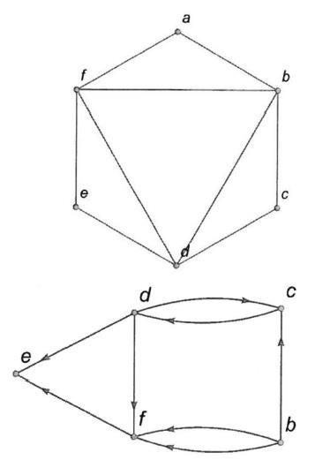

1. The elements 32, 15, 20, 30, 12, 25, 16 are inserted one by one in the given order into a Min Heap.
   1. Draw the resulting Min heap.
   2. Using the Min heap you just draw, what is the running time to sorted the elements in ascending order? Give a big-Oh characterization, in terms of the number of elements .
2. Given a hash table of size 13, show the contents of your hash table after inserting the values {8, 2, 7, 18, 15, 19, 23, 15, 20, 16} using the following methods:
   1. Show the contents of your hash table after inserting the values {8, 2, 7, 18, 15, 19, 23, 15, 20, 16} using separate chaining for collision resolution.
   2. Show the contents of your hash table after inserting the values {8, 2, 7, 18, 15, 19, 23, 15, 20, 16} using open addressing with linear probing ( ( ) = ) for collision resolution.
   3. In addition, what is the load factor ?